# Introduction

## Overview

Measuring the Pulse of Prosperity is an index of economic freedom analysis that provides a comprehensive assessment of economic freedom around the world. The analysis is based on ten key indicators of economic freedom, which are grouped into four categories: Rule of Law, Government Size, Regulatory Efficiency, and Open Markets.

Each indicator is scored on a scale of 0 to 100, with higher scores indicating greater economic freedom. The overall index is calculated as an average of the ten indicator scores, with countries ranked from highest to lowest based on their overall score.

The index provides valuable insights into the relationship between economic freedom and prosperity. Countries with high levels of economic freedom tend to have higher levels of economic growth, job creation, and overall prosperity. On the other hand, countries with low levels of economic freedom tend to experience slower economic growth, higher levels of poverty, and lower levels of overall prosperity.

Measuring the Pulse of Prosperity index is produced by The Heritage Foundation, a conservative think-tank based in the United States. The index is updated annually and provides a valuable tool for policymakers, investors, and analysts seeking to understand the economic landscape of different countries around the world.

## Purpose

The purpose of measuring the Pulse of Prosperity index of economic freedom analysis is to provide a comprehensive assessment of the economic freedom of different countries around the world. The index is designed to measure the extent to which a country's economic policies and institutions support economic freedom, which is considered essential for promoting economic growth, job creation, and overall prosperity.

The index provides policymakers, investors, and analysts with valuable insights into the economic landscape of different countries, enabling them to make informed decisions about investment, trade, and other economic activities. By highlighting the relationship between economic freedom and prosperity, the index also provides a framework for policymakers to develop policies that promote economic freedom and improve the economic well-being of their citizens.

Furthermore, the index serves as a tool for benchmarking economic freedom across different countries and regions, helping to identify best practices and areas for improvement. This enables policymakers to learn from the experiences of other countries and implement policies that are tailored to their own unique economic circumstances

Overall, the purpose of the Pulse of Prosperity index of economic freedom analysis is to promote economic freedom as a key driver of economic growth and prosperity, and to provide policymakers with the information and tools they need to create policies that support economic freedom and promote the economic well-being of their citizens

# Problem Definition & Design Thinking

## Empathy Map

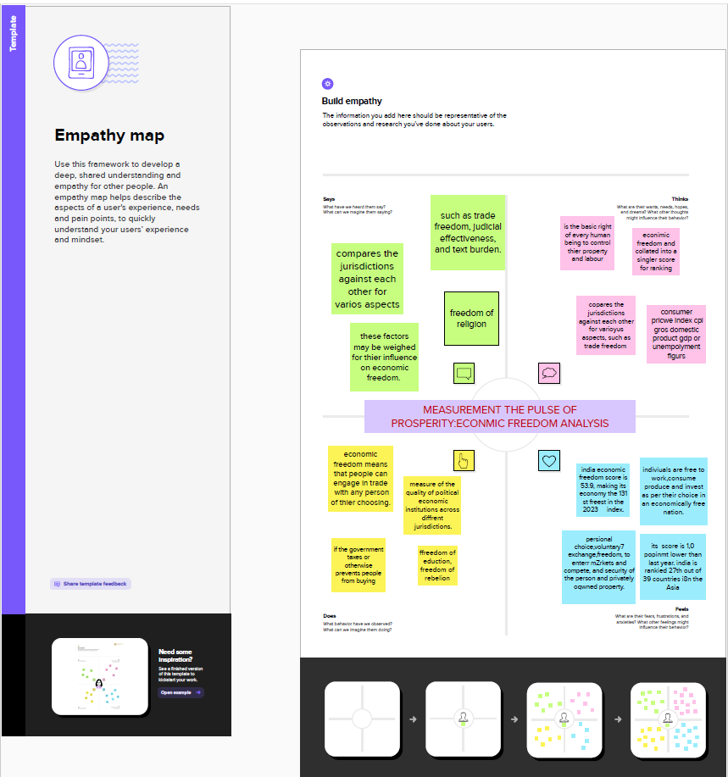

## Ideation & Brainstorming Map

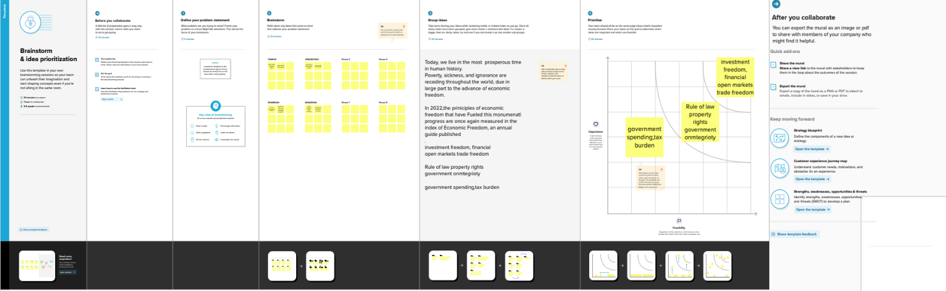

# Results

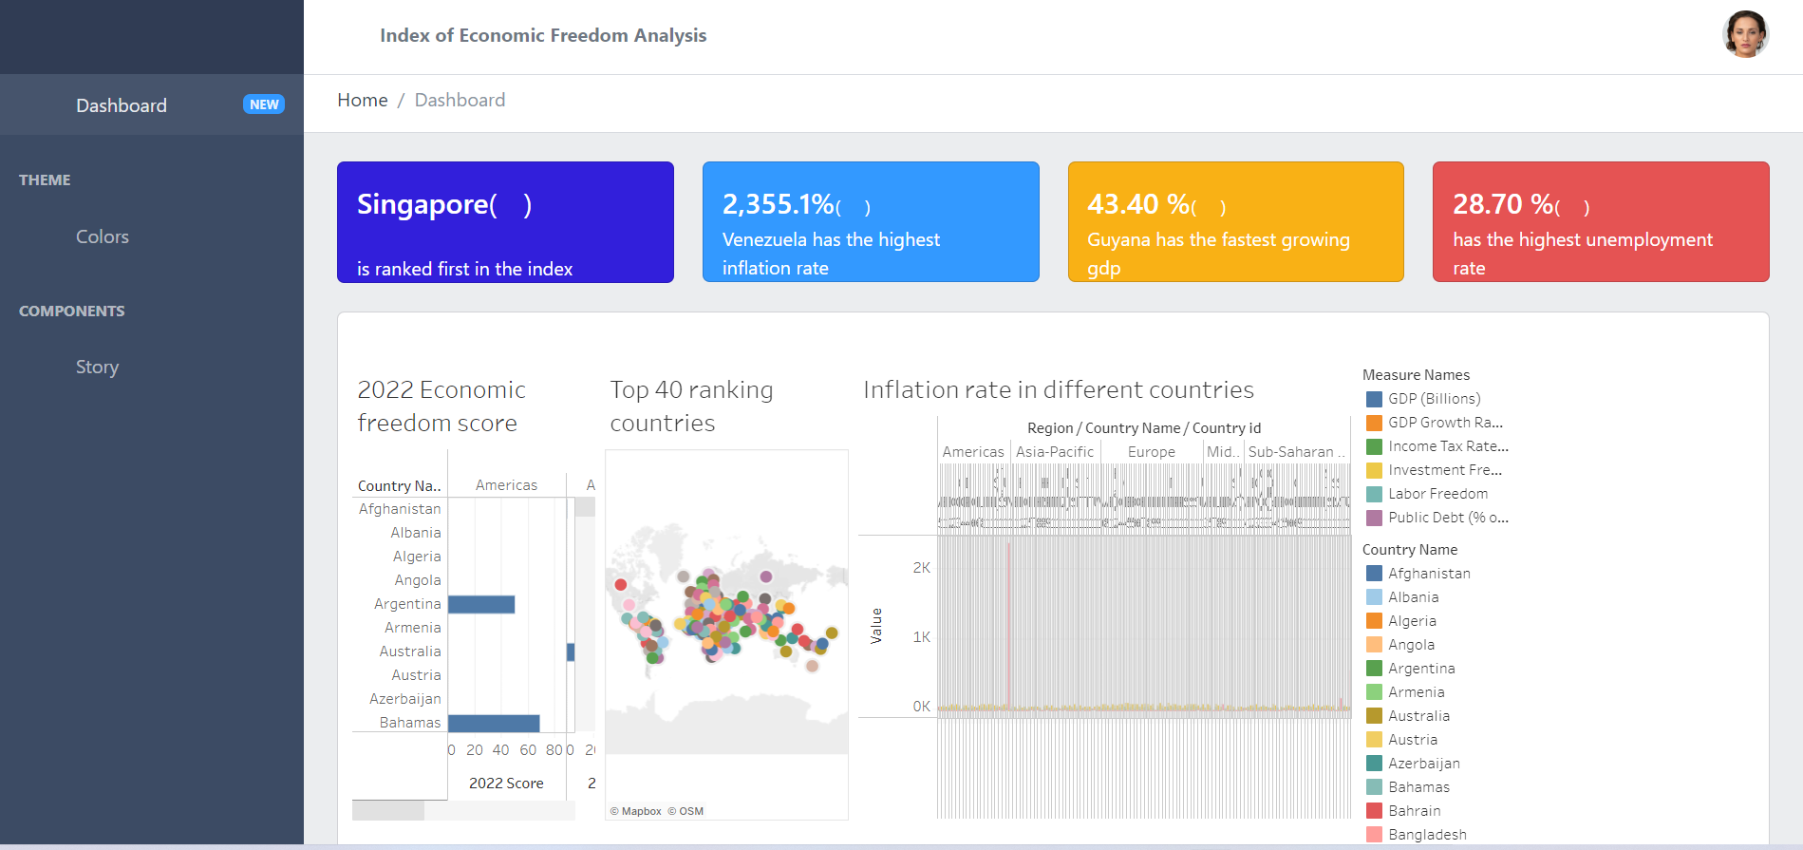

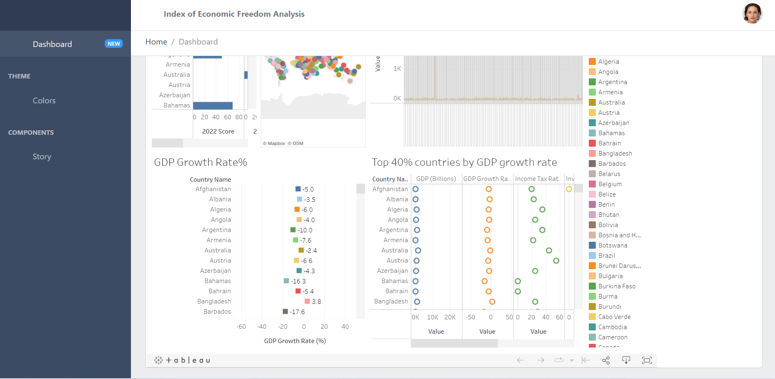

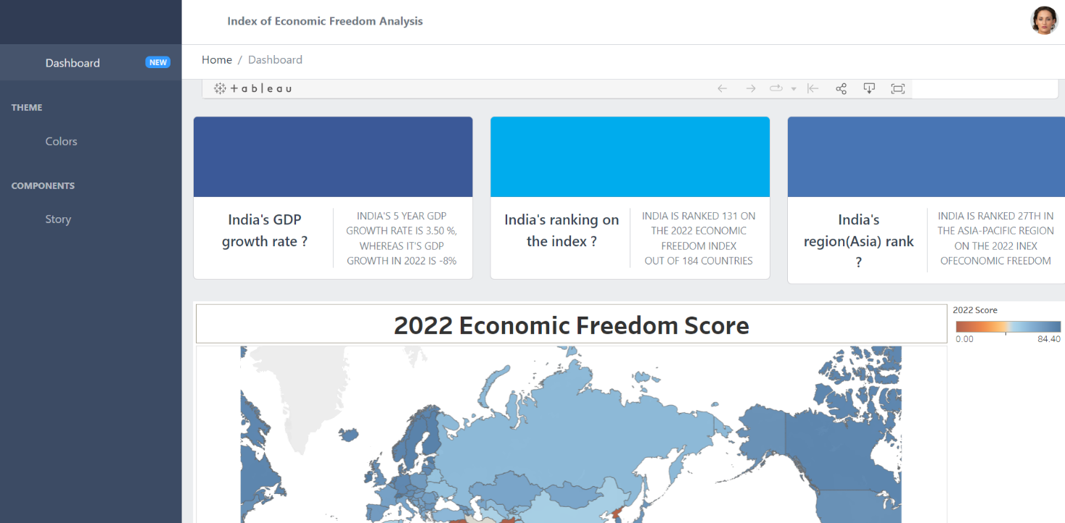

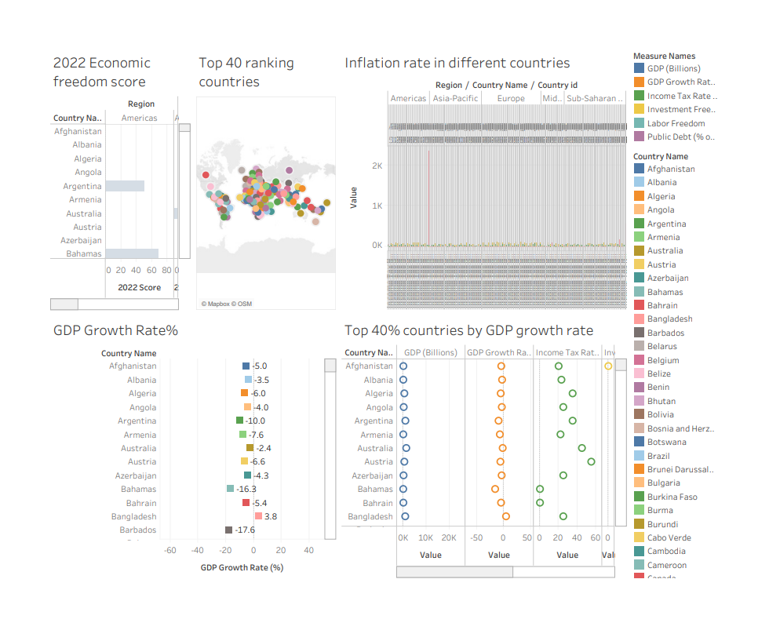

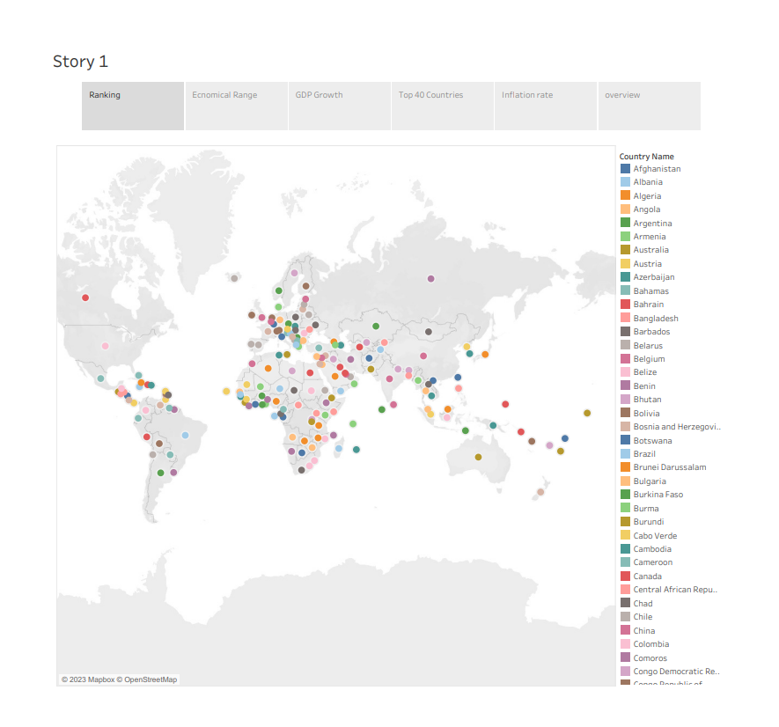

# Advantages & disadvantages

## Advantages

# Comprehensive assessment: The index provides a comprehensive assessment of economic freedom by examining ten key indicators across four categories, providing a detailed picture of a country's economic policies and institutions

# International comparison: The index allows for international comparison of economic freedom across different countries and regions, providing policymakers with valuable information on best practices and areas for improvement.

# Transparency: The index is transparent, with clear methodology and data sources, allowing for independent verification of results and ensuring credibility.

# Longitudinal analysis: The index has been updated annually for several decades, allowing for longitudinal analysis of changes in economic freedom over time and providing valuable insights into the effects of policy changes.

# Policy relevance: The index is policy-relevant, providing policymakers with actionable information on the economic policies and institutions that are most likely to promote economic growth, job creation, and overall prosperity.

# Focus on economic freedom: The index focuses on economic freedom as a key driver of economic growth and prosperity, providing a framework for policymakers to develop policies that promote economic freedom and improve the economic well-being of their citizens.

## 4.2 Disadvantages

# Simplification of complex issues: The index uses a simplified set of indicators to measure economic freedom, which may not capture the full complexity of economic policies and institutions in a given country.

# Ideological bias: The index is produced by The Heritage Foundation, which is a conservative think-tank based in the United States, and may be influenced by ideological biases that could affect its methodology and interpretation of results.

# Limited scope: The index focuses primarily on economic freedom and does not account for other factors that may contribute to economic growth and prosperity, such as social and environmental policies.

# Data quality: The accuracy and reliability of the data used in the index may vary across countries, leading to potential biases and inaccuracies in the results.

# Lack of contextualization: The index provides a standardized ranking of economic freedom across different countries, but may not take into account the unique economic, social, and political contexts of each country.

# 5. Applications

# Investment decisions: The index can help investors to make informed decisions about where to invest their money, by providing information on the economic policies and institutions of different countries and their impact on economic growth and prosperity.

# Trade negotiations: The index can be used in trade negotiations to assess the economic policies of different countries and to identify areas where trade agreements could be strengthened to promote economic freedom.

# Policy development: The index can be used by policymakers to identify areas where policy changes could be made to improve economic freedom and promote economic growth and prosperity.

# Business decisions: The index can help businesses to make informed decisions about where to establish operations or to expand their existing operations, by providing information on the economic policies and institutions of different countries and their impact on business freedom.

# International development: The index can be used by international development organizations to assess the economic policies of different countries and to identify areas where support can be provided to promote economic freedom and improve the economic well-being of citizens.

# Overall, the Pulse of Prosperity index of economic freedom analysis is a valuable tool for a range of stakeholders across different sectors and industries, providing information and insights that can help to promote economic freedom and improve the economic well-being of citizens around the world.

# Conclusion

+ In conclusion, measuring the pulse of prosperity through an index of economic freedom analysis can provide valuable insights into the economic conditions of a country. Economic freedom is a critical component of a prosperous economy, and the higher the level of economic freedom, the more likely a country is to experience sustained economic growth and development.

An index of economic freedom analysis provides a comprehensive framework for assessing the level of economic freedom in a country. This analysis examines various factors that contribute to economic freedom, including the legal system, regulatory environment, property rights, and government intervention in the economy.

Countries with higher levels of economic freedom tend to have more efficient markets, lower levels of corruption, higher per capita income, and better standards of living for their citizens. They also tend to attract more foreign investment, which can lead to further economic growth and development.

In summary, measuring the pulse of prosperity through an index of economic freedom analysis is an essential tool for understanding the economic conditions of a country. Countries that prioritize economic freedom tend to have better economic outcomes and provide better opportunities for their citizens to achieve prosperity.

# Future scope

# The future scope for measuring the pulse of prosperity through an index of economic freedom analysis is significant. As countries continue to develop and grow, understanding the factors that contribute to economic freedom will become increasingly important. Here are some potential future directions for this type of analysis:

# Regional comparisons: Currently, most index of economic freedom analyses focus on individual countries. However, there is potential for comparative analysis of regions or economic blocs. This could help identify areas where regional cooperation could lead to increased economic freedom and prosperity.

# Incorporating new metrics: As the world changes, new metrics may become important for measuring economic freedom. For example, the growing importance of data privacy and cybersecurity could become important components of future economic freedom analyses.

# Longitudinal analysis: Index of economic freedom analyses typically examine data from a single year. However, analyzing trends over time could provide valuable insights into how economic freedom changes over the long term.

# Climate change and sustainability: With the growing recognition of the importance of sustainability, future analyses could incorporate metrics related to climate change and sustainable development. This could help identify ways in which economic freedom can be balanced with environmental concerns.

Overall, measuring the pulse of prosperity through an index of economic freedom analysis will continue to be an important tool for understanding and promoting economic growth and development. As the world evolves, it will be important to adapt these analyses to incorporate new metrics and reflect changing economic and environmental conditions.

# Appendix

## HTML code for the output web page

<!DOCTYPE html>

<!--

* CoreUI - Free Bootstrap Admin Template

* @version v4.2.2

* @link https://coreui.io

* Copyright (c) 2022 creativeLabs Łukasz Holeczek

* Licensed under MIT (https://coreui.io/license)

-->

<!-- Breadcrumb-->

<html lang="en">

  <head>

    <base href="./">

    <meta charset="utf-8">

    <meta http-equiv="X-UA-Compatible" content="IE=edge">

    <meta name="viewport" content="width=device-width, initial-scale=1.0, shrink-to-fit=no">

    <meta name="description" content="CoreUI - Open Source Bootstrap Admin Template">

    <meta name="author" content="Łukasz Holeczek">

    <meta name="keyword" content="Bootstrap,Admin,Template,Open,Source,jQuery,CSS,HTML,RWD,Dashboard">

    <title>Index of Economic Freedom Analysis</title>

    <link rel="apple-touch-icon" sizes="57x57" href="assets/favicon/apple-icon-57x57.png">

    <link rel="apple-touch-icon" sizes="60x60" href="assets/favicon/apple-icon-60x60.png">

    <link rel="apple-touch-icon" sizes="72x72" href="assets/favicon/apple-icon-72x72.png">

    <link rel="apple-touch-icon" sizes="76x76" href="assets/favicon/apple-icon-76x76.png">

    <link rel="apple-touch-icon" sizes="114x114" href="assets/favicon/apple-icon-114x114.png">

    <link rel="apple-touch-icon" sizes="120x120" href="assets/favicon/apple-icon-120x120.png">

    <link rel="apple-touch-icon" sizes="144x144" href="assets/favicon/apple-icon-144x144.png">

    <link rel="apple-touch-icon" sizes="152x152" href="assets/favicon/apple-icon-152x152.png">

    <link rel="apple-touch-icon" sizes="180x180" href="assets/favicon/apple-icon-180x180.png">

    <link rel="icon" type="image/png" sizes="192x192" href="assets/favicon/android-icon-192x192.png">

    <link rel="icon" type="image/png" sizes="32x32" href="assets/favicon/favicon-32x32.png">

    <link rel="icon" type="image/png" sizes="96x96" href="assets/favicon/favicon-96x96.png">

    <link rel="icon" type="image/png" sizes="16x16" href="assets/favicon/favicon-16x16.png">

    <link rel="manifest" href="assets/favicon/manifest.json">

    <meta name="msapplication-TileColor" content="#ffffff">

    <meta name="msapplication-TileImage" content="assets/favicon/ms-icon-144x144.png">

    <meta name="theme-color" content="#ffffff">

    <!-- Vendors styles-->

    <link rel="stylesheet" href="vendors/simplebar/css/simplebar.css">

    <link rel="stylesheet" href="css/vendors/simplebar.css">

    <!-- Main styles for this application-->

    <link href="css/style.css" rel="stylesheet">

    <!-- We use those styles to show code examples, you should remove them in your application.-->

    <link rel="stylesheet" href="https://cdn.jsdelivr.net/npm/prismjs@1.23.0/themes/prism.css">

    <link href="css/examples.css" rel="stylesheet">

    <!-- Global site tag (gtag.js) - Google Analytics-->

    <script async="" src="https://www.googletagmanager.com/gtag/js?id=UA-118965717-3"></script>

    <script>

      window.dataLayer = window.dataLayer || [];

      function gtag() {

        dataLayer.push(arguments);

      }

      gtag('js', new Date());

      // Shared ID

      gtag('config', 'UA-118965717-3');

      // Bootstrap ID

      gtag('config', 'UA-118965717-5');

    </script>

    <link href="vendors/@coreui/chartjs/css/coreui-chartjs.css" rel="stylesheet">

  </head>

  <body>

    <div class="sidebar sidebar-dark sidebar-fixed" id="sidebar">

      <div class="sidebar-brand d-none d-md-flex">

        <svg class="sidebar-brand-full" width="118" height="46" alt="CoreUI Logo">

           <use xlink:href="assets/brand/coreui.svg#full"></use>

        </svg>

        <svg class="sidebar-brand-narrow" width="46" height="46" alt="CoreUI Logo">

          <use xlink:href="assets/brand/coreui.svg#signet"></use>

        </svg>

      </div>

      <ul class="sidebar-nav" data-coreui="navigation" data-simplebar="">

        <li class="nav-item"><a class="nav-link" href="index.html">

            <svg class="nav-icon">

              <use xlink:href="vendors/@coreui/icons/svg/free.svg#cil-speedometer"></use>

            </svg> Dashboard<span class="badge badge-sm bg-info ms-auto">NEW</span></a></li>

        <li class="nav-title">Theme</li>

        <li class="nav-item"><a class="nav-link" href="colors.html">

            <svg class="nav-icon">

              <use xlink:href="vendors/@coreui/icons/svg/free.svg#cil-drop"></use>

            </svg> Colors</a></li>

        <!-- <li class="nav-item"><a class="nav-link" href="typography.html">

            <svg class="nav-icon">

              <use xlink:href="vendors/@coreui/icons/svg/free.svg#cil-pencil"></use>

            </svg> Typography</a></li> -->

        <li class="nav-title">Components</li>

        <li class="nav-item"><a class="nav-link" href="story.html">

            <svg class="nav-icon">

              <use xlink:href="vendors/@coreui/icons/svg/free.svg#cil-chart-pie"></use>

            </svg>Story</a></li>

    </div>

    <div class="wrapper d-flex flex-column min-vh-100 bg-light">

      <header class="header header-sticky mb-4">

        <div class="container-fluid">

          <button class="header-toggler px-md-0 me-md-3" type="button" onclick="coreui.Sidebar.getInstance(document.querySelector('#sidebar')).toggle()">

            <svg class="icon icon-lg">

              <use xlink:href="vendors/@coreui/icons/svg/free.svg#cil-menu"></use>

            </svg>

          </button><a class="header-brand d-md-none" href="#">

            <svg width="100" height="46" alt="CoreUI Logo">

              <use xlink:href="assets/brand/coreui.svg#cib-reddit-alt"></use>

            </svg></a>

          <ul class="header-nav d-none d-md-flex">

            <li class="nav-item"><a class="nav-link" href="#"><b>Index of Economic Freedom Analysis</b></a></li>

            <!-- <li class="nav-item"><a class="nav-link" href="#">Users</a></li>

            <li class="nav-item"><a class="nav-link" href="#">Settings</a></li> -->

          </ul>

          <ul class="header-nav ms-auto">

            <!-- <li class="nav-item"><a class="nav-link" href="#">

                <svg class="icon icon-lg">

                  <use xlink:href="vendors/@coreui/icons/svg/free.svg#cil-bell"></use>

                </svg></a></li> -->

            <!-- <li class="nav-item"><a class="nav-link" href="#">

                <svg class="icon icon-lg">

                  <use xlink:href="vendors/@coreui/icons/svg/free.svg#cil-list-rich"></use>

                </svg></a></li> -->

            <!-- <li class="nav-item"><a class="nav-link" href="#">

                <svg class="icon icon-lg">

                  <use xlink:href="vendors/@coreui/icons/svg/free.svg#cil-envelope-open"></use>

                </svg></a></li> -->

          </ul>

          <ul class="header-nav ms-3">

            <li class="nav-item dropdown"><a class="nav-link py-0" data-coreui-toggle="dropdown" href="#" role="button" aria-haspopup="true" aria-expanded="false">

                <div class="avatar avatar-md"><img class="avatar-img" src="assets/img/avatars/8.jpg" alt="user@email.com"></div>

              </a>

              <div class="dropdown-menu dropdown-menu-end pt-0">

                <div class="dropdown-header bg-light py-2">

                  <div class="fw-semibold">Account</div>

                </div><a class="dropdown-item" href="#">

                  <!-- <svg class="icon me-2">

                    <use xlink:href="vendors/@coreui/icons/svg/free.svg#cil-bell"></use>

                  </svg> Updates<span class="badge badge-sm bg-info ms-2">42</span></a><a class="dropdown-item" href="#"> -->

                  <!-- <svg class="icon me-2">

                    <use xlink:href="vendors/@coreui/icons/svg/free.svg#cil-envelope-open"></use>

                  </svg> Messages<span class="badge badge-sm bg-success ms-2">42</span></a><a class="dropdown-item" href="#"> -->

                  <!-- <svg class="icon me-2">

                    <use xlink:href="vendors/@coreui/icons/svg/free.svg#cil-task"></use>

                  </svg> Tasks<span class="badge badge-sm bg-danger ms-2">42</span></a><a class="dropdown-item" href="#"> -->

                  <!-- <svg class="icon me-2">

                    <use xlink:href="vendors/@coreui/icons/svg/free.svg#cil-comment-square"></use>

                  </svg> Comments<span class="badge badge-sm bg-warning ms-2">42</span></a> -->

                <!-- <div class="dropdown-header bg-light py-2">

                  <div class="fw-semibold">Settings</div>

                </div><a class="dropdown-item" href="#"> -->

                  <!-- <svg class="icon me-2">

                    <use xlink:href="vendors/@coreui/icons/svg/free.svg#cil-user"></use>

                  </svg> Profile</a><a class="dropdown-item" href="#"> -->

                  <!-- <svg class="icon me-2">

                    <use xlink:href="vendors/@coreui/icons/svg/free.svg#cil-settings"></use>

                  </svg> Settings</a><a class="dropdown-item" href="#"> -->

                  <!-- <svg class="icon me-2">

                    <use xlink:href="vendors/@coreui/icons/svg/free.svg#cil-credit-card"></use>

                  </svg> Payments<span class="badge badge-sm bg-secondary ms-2">42</span></a><a class="dropdown-item" href="#"> -->

                  <!-- <svg class="icon me-2">

                    <use xlink:href="vendors/@coreui/icons/svg/free.svg#cil-file"></use>

                  </svg> Projects<span class="badge badge-sm bg-primary ms-2">42</span></a> -->

                <!-- <div class="dropdown-divider"></div><a class="dropdown-item" href="#"> -->

                  <!-- <svg class="icon me-2">

                    <use xlink:href="vendors/@coreui/icons/svg/free.svg#cil-lock-locked"></use>

                  </svg> Lock Account</a><a class="dropdown-item" href="#"> -->

                  <!-- <svg class="icon me-2">

                    <use xlink:href="vendors/@coreui/icons/svg/free.svg#cil-account-logout"></use>

                  </svg> Logout</a> -->

              </div>

            </li>

          </ul>

        </div>

        <div class="header-divider"></div>

        <div class="container-fluid">

          <nav aria-label="breadcrumb">

            <ol class="breadcrumb my-0 ms-2">

              <li class="breadcrumb-item">

                <!-- if breadcrumb is single--><span>Home</span>

              </li>

              <li class="breadcrumb-item active"><span>Dashboard</span></li>

            </ol>

          </nav>

        </div>

      </header>

      <div class="body flex-grow-1 px-3">

        <div class="container-lg">

          <div class="row">

            <div class="col-sm-6 col-lg-3">

              <div class="card mb-4 text-white bg-primary">

                <div class="card-body pb-0 d-flex justify-content-between align-items-start">

                  <div>

                    <div class="fs-4 fw-semibold" style="padding-bottom: 25px;">Singapore<span class="fs-4 fw-normal">(

                      <svg class="icon">

                        <use xlink:href="vendors/@coreui/icons/svg/flag.svg#cif-sg"></use>

                      </svg>)</span></div>

                    <div>is ranked first in the index </div>

                  </div>

                  <div class="dropdown">

                    <button class="btn btn-transparent text-white p-0" type="button" data-coreui-toggle="dropdown" aria-haspopup="true" aria-expanded="false">

                      <svg class="icon">

                        <use xlink:href="vendors/@coreui/icons/svg/free.svg#cil-options"></use>

                      </svg>

                    </button>

                    <div class="dropdown-menu dropdown-menu-end"><a class="dropdown-item" href="#">Action</a><a class="dropdown-item" href="#">Another action</a><a class="dropdown-item" href="#">Something else here</a></div>

                  </div>

                </div>

                <!-- <div class="c-chart-wrapper mt-3 mx-3" style="height:70px;">

                  <canvas class="chart" id="card-chart1" height="70"></canvas>

                </div> -->

              </div>

            </div>

            <!-- /.col-->

            <div class="col-sm-6 col-lg-3">

              <div class="card mb-4 text-white bg-info">

                <div class="card-body pb-0 d-flex justify-content-between align-items-start">

                  <div>

                    <div class="fs-4 fw-semibold">2,355.1%<span class="fs-6 fw-normal">(

                        <svg class="icon">

                          <use xlink:href="vendors/@coreui/icons/svg/flag.svg#cif-ve"></use>

                        </svg>)</span></div>

                    <div>Venezuela has the highest inflation rate</div>

                  </div>

                  <div class="dropdown">

                    <button class="btn btn-transparent text-white p-0" type="button" data-coreui-toggle="dropdown" aria-haspopup="true" aria-expanded="false">

                      <svg class="icon">

                        <use xlink:href="vendors/@coreui/icons/svg/free.svg#cil-options"></use>

                      </svg>

                    </button>

                    <div class="dropdown-menu dropdown-menu-end"><a class="dropdown-item" href="#">Action</a><a class="dropdown-item" href="#">Another action</a><a class="dropdown-item" href="#">Something else here</a></div>

                  </div>

                </div>

                <!-- <div class="c-chart-wrapper mt-3 mx-3" style="height:70px;">

                  <canvas class="chart" id="card-chart2" height="70"></canvas>

                </div> -->

              </div>

            </div>

            <!-- /.col-->

            <div class="col-sm-6 col-lg-3">

              <div class="card mb-4 text-white bg-warning">

                <div class="card-body pb-0 d-flex justify-content-between align-items-start">

                  <div>

                    <div class="fs-4 fw-semibold">43.40 %<span class="fs-6 fw-normal">(

                        <svg class="icon">

                          <use xlink:href="vendors/@coreui/icons/svg/flag.svg#cif-gy"></use>

                        </svg>)</span></div>

                    <div>Guyana has the fastest growing gdp</div>

                  </div>

                  <div class="dropdown">

                    <button class="btn btn-transparent text-white p-0" type="button" data-coreui-toggle="dropdown" aria-haspopup="true" aria-expanded="false">

                      <svg class="icon">

                        <use xlink:href="vendors/@coreui/icons/svg/free.svg#cil-options"></use>

                      </svg>

                    </button>

                    <div class="dropdown-menu dropdown-menu-end"><a class="dropdown-item" href="#">Action</a><a class="dropdown-item" href="#">Another action</a><a class="dropdown-item" href="#">Something else here</a></div>

                  </div>

                </div>

                <!-- <div class="c-chart-wrapper mt-3" style="height:70px;">

                  <canvas class="chart" id="card-chart3" height="70"></canvas>

                </div> -->

              </div>

            </div>

            <!-- /.col-->

            <div class="col-sm-6 col-lg-3">

              <div class="card mb-4 text-white bg-danger">

                <div class="card-body pb-0 d-flex justify-content-between align-items-start">

                  <div>

                    <div class="fs-4 fw-semibold">28.70 %<span class="fs-6 fw-normal">(

                        <svg class="icon">

                          <use xlink:href="vendors/@coreui/icons/svg/flag.svg#cif-za"></use>

                        </svg>)</span></div>

                    <div> has the highest unemployment rate</div>

                  </div>

                  <div class="dropdown">

                    <button class="btn btn-transparent text-white p-0" type="button" data-coreui-toggle="dropdown" aria-haspopup="true" aria-expanded="false">

                      <svg class="icon">

                        <use xlink:href="vendors/@coreui/icons/svg/free.svg#cil-options"></use>

                      </svg>

                    </button>

                    <div class="dropdown-menu dropdown-menu-end"><a class="dropdown-item" href="#">Action</a><a class="dropdown-item" href="#">Another action</a><a class="dropdown-item" href="#">Something else here</a></div>

                  </div>

                </div>

                <!-- <div class="c-chart-wrapper mt-3 mx-3" style="height:70px;">

                  <canvas class="chart" id="card-chart4" height="70"></canvas>

                </div> -->

              </div>

            </div>

            <!-- /.col-->

          </div>

          <!-- /.row-->

          <div class="card mb-4">

            <div class="card-body">

              <div class="d-flex justify-content-between">

                </div>

              </div>

              <div class='tableauPlaceholder' id='viz1681999367241' style='position: relative'><noscript><a href='#'><img alt='Dashboard 1 ' src='https:&#47;&#47;public.tableau.com&#47;static&#47;images&#47;2T&#47;2TYGCG4F2&#47;1_rss.png' style='border: none' /></a></noscript><object class='tableauViz'  style='display:none;'><param name='host_url' value='https%3A%2F%2Fpublic.tableau.com%2F' /> <param name='embed_code_version' value='3' /> <param name='path' value='shared&#47;2TYGCG4F2' /> <param name='toolbar' value='yes' /><param name='static_image' value='https:&#47;&#47;public.tableau.com&#47;static&#47;images&#47;2T&#47;2TYGCG4F2&#47;1.png' /> <param name='animate_transition' value='yes' /><param name='display_static_image' value='yes' /><param name='display_spinner' value='yes' /><param name='display_overlay' value='yes' /><param name='display_count' value='yes' /><param name='language' value='en-US' /><param name='filter' value='publish=' /></object></div>                <script type='text/javascript'>                    var divElement = document.getElementById('viz1681999367241');                    var vizElement = divElement.getElementsByTagName('object')[0];                    if ( divElement.offsetWidth > 800 ) { vizElement.style.width='1000px';vizElement.style.height='827px';} else if ( divElement.offsetWidth > 500 ) { vizElement.style.width='1000px';vizElement.style.height='827px';} else { vizElement.style.width='100%';vizElement.style.height='1627px';}                     var scriptElement = document.createElement('script');                    scriptElement.src = 'https://public.tableau.com/javascripts/api/viz_v1.js';                    vizElement.parentNode.insertBefore(scriptElement, vizElement);                </script>

            </div>

          </div>

          <!-- /.card.mb-4-->

          <div class="row">

            <div class="col-sm-6 col-lg-4">

              <div class="card mb-4" style="--cui-card-cap-bg: #3b5998">

                <div class="card-header position-relative d-flex justify-content-center align-items-center">

                  <svg class="icon icon-3xl text-white my-4">

                    <use xlink:href="vendors/@coreui/icons/svg/flag.svg#cif-in"></use>

                  </svg>

                  <div class="chart-wrapper position-absolute top-0 start-0 w-100 h-100">

                    <canvas id="social-box-chart-1" height="90"></canvas>

                  </div>

                </div>

                <div class="card-body row text-center">

                  <div class="col">

                    <div class="fs-5 fw-semibold">India's GDP  growth rate ?</div>

                    <div class="fs-5 fw-semibold"></div>

                  </div>

                  <div class="vr"></div>

                  <div class="col">

                    <div class="text-uppercase text-medium-emphasis small">India's 5 year GDP growth rate is 3.50 %,</div>

                    <div class="text-uppercase text-medium-emphasis small">whereas it's GDP growth in 2022 is -8%</div>

                  </div>

                </div>

              </div>

            </div>

            <!-- /.col-->

            <div class="col-sm-6 col-lg-4">

              <div class="card mb-4" style="--cui-card-cap-bg: #00aced">

                <div class="card-header position-relative d-flex justify-content-center align-items-center">

                  <svg class="icon icon-3xl text-white my-4">

                    <use xlink:href="vendors/@coreui/icons/svg/flag.svg#cif-in"></use>

                  </svg>

                  <div class="chart-wrapper position-absolute top-0 start-0 w-100 h-100">

                    <canvas id="social-box-chart-2" height="90"></canvas>

                  </div>

                </div>

                <div class="card-body row text-center">

                  <div class="col">

                    <div class="fs-5 fw-semibold">India's ranking on the index ?</div>

                    <div class="text-uppercase text-medium-emphasis small"></div>

                  </div>

                  <div class="vr"></div>

                  <div class="col">

                    <div class="text-uppercase text-medium-emphasis small">India is ranked 131 on the 2022 economic freedom index </div>

                    <div class="text-uppercase text-medium-emphasis small">out of 184 countries</div>

                  </div>

                </div>

              </div>

            </div>

            <!-- /.col-->

            <div class="col-sm-6 col-lg-4">

              <div class="card mb-4" style="--cui-card-cap-bg: #4875b4">

                <div class="card-header position-relative d-flex justify-content-center align-items-center">

                  <svg class="icon icon-3xl text-white my-4">

                    <use xlink:href="vendors/@coreui/icons/svg/flag.svg#cif-in"></use>

                  </svg>

                  <div class="chart-wrapper position-absolute top-0 start-0 w-100 h-100">

                    <canvas id="social-box-chart-3" height="90"></canvas>

                  </div>

                </div>

                <div class="card-body row text-center">

                  <div class="col">

                    <div class="fs-5 fw-semibold">India's region(Asia) rank ? </div>

                    <div class="text-uppercase text-medium-emphasis small"></div>

                  </div>

                  <div class="vr"></div>

                  <div class="col">

                    <div class="fs-5 fw-semibold"></div>

                    <div class="text-uppercase text-medium-emphasis small">India is ranked 27th in the asia-pacific region on the 2022 Inex ofeconomic freedom</div>

                  </div>

                </div>

              </div>

            </div>

            <div class='tableauPlaceholder' id='viz1672314528873' style='position: relative'><noscript><a href='#'><img alt='2022 Economic Freedom Score ' src='https:&#47;&#47;public.tableau.com&#47;static&#47;images&#47;ec&#47;economic_freedom_score_2022&#47;2022EconomicFreedomScore&#47;1_rss.png' style='border: none' /></a></noscript><object class='tableauViz'  style='display:none;'><param name='host_url' value='https%3A%2F%2Fpublic.tableau.com%2F' /> <param name='embed_code_version' value='3' /> <param name='site_root' value='' /><param name='name' value='economic_freedom_score_2022&#47;2022EconomicFreedomScore' /><param name='tabs' value='no' /><param name='toolbar' value='yes' /><param name='static_image' value='https:&#47;&#47;public.tableau.com&#47;static&#47;images&#47;ec&#47;economic_freedom_score_2022&#47;2022EconomicFreedomScore&#47;1.png' /> <param name='animate_transition' value='yes' /><param name='display_static_image' value='yes' /><param name='display_spinner' value='yes' /><param name='display_overlay' value='yes' /><param name='display_count' value='yes' /><param name='language' value='en-US' /><param name='filter' value='publish=yes' /></object></div>                <script type='text/javascript'>                    var divElement = document.getElementById('viz1672314528873');                    var vizElement = divElement.getElementsByTagName('object')[0];                    vizElement.style.width='100%';vizElement.style.height=(divElement.offsetWidth*0.75)+'px';                    var scriptElement = document.createElement('script');                    scriptElement.src = 'https://public.tableau.com/javascripts/api/viz_v1.js';                    vizElement.parentNode.insertBefore(scriptElement, vizElement);                </script>

                            <div class="dropdown dropup">

                              <button class="btn btn-transparent p-0" type="button" data-coreui-toggle="dropdown" aria-haspopup="true" aria-expanded="false">

                                <!-- <svg class="icon"> -->

                                  <use xlink:href="vendors/@coreui/icons/svg/free.svg#cil-options"></use>

                                </svg>

                              </button>

                              <div class="dropdown-menu dropdown-menu-end"><a class="dropdown-item" href="#">Info</a><a class="dropdown-item" href="#">Edit</a><a class="dropdown-item text-danger" href="#">Delete</a></div>

                            </div>

                          </td>

                        </tr>

                      </tbody>

                    </table>

                  </div>

                </div>

              </div>

            </div>

            <!-- /.col-->

          </div>

          <!-- /.row-->

        </div>

      </div>

      <footer class="footer">

        <div><a href=></a><a href=></a> © 2022 SmartInternz.</div>

        <div class="ms-auto">More about&nbsp;<a href="https://smartinternz.com/"> SmartInternz</a></div>

      </footer>

    </div>

    <!-- CoreUI and necessary plugins-->

    <script src="vendors/@coreui/coreui/js/coreui.bundle.min.js"></script>

    <script src="vendors/simplebar/js/simplebar.min.js"></script>

    <!-- Plugins and scripts required by this view-->

    <script src="vendors/chart.js/js/chart.min.js"></script>

    <script src="vendors/@coreui/chartjs/js/coreui-chartjs.js"></script>

    <script src="vendors/@coreui/utils/js/coreui-utils.js"></script>

    <script src="js/main.js"></script>

    <script>

    </script>

  </body>

</html>